Question 1: Reflex Agent Evaluation Function (8 points)

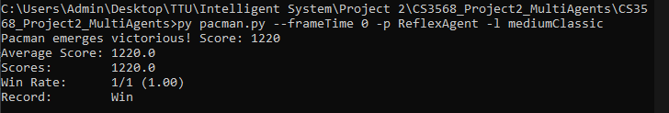

Question 2: Minimax (10 points)

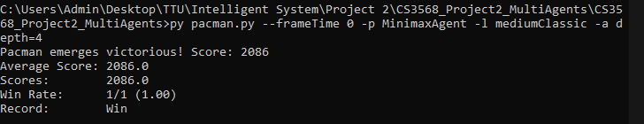

Question 3: AlphaBeta Pruning (10 points)

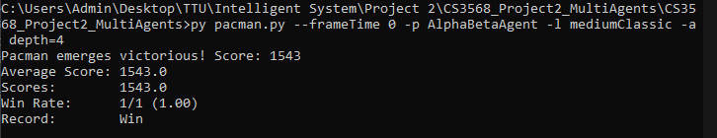

Question 4: Exceptimax (10 points) –

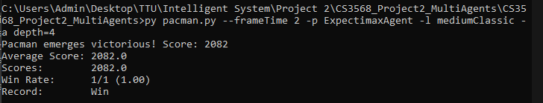

Question 5: Better Evaluation Function (12 points) –

